**VIVE**

VRSettings.supportedDevices

Other VR Head Mounted Displays (HMDs) will also work with Unity, such as the HTC Vive, and this documentation will be updated in future to cover additional VR platforms.

While most of this content will be relevant for all VR HMDs, please see the manufacturer's documentation for more details.

<https://unity3d.com/learn/tutorials/topics/virtual-reality/vr-overview>

### Enabling VR in Unity projects

Please be sure that you have the [Oculus runtime 0.8 installed](https://developer.oculus.com/downloads/), along with [Unity 5.3 or higher](https://unity3d.com/ru/get-unity/download).

VR support is enabled by visiting Edit > Project Settings> Player > Other Settings > Rendering.

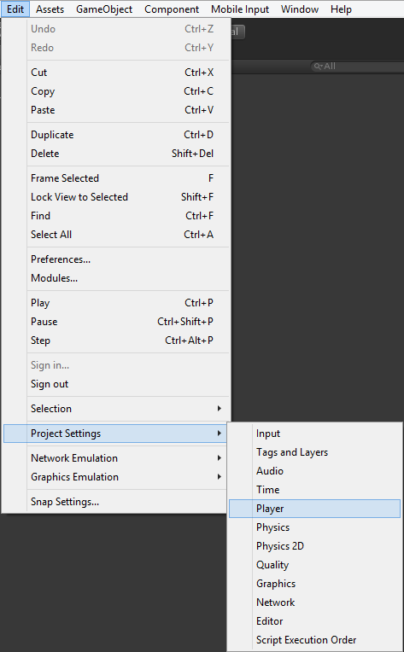

Then enabling the “Virtual Reality Supported” checkbox in the Inspector.

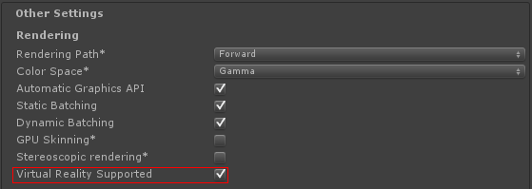

During runtime, this can be toggled using the [UnityEngine.VR.VRSettings.enabled](http://docs.unity3d.com/ScriptReference/VR.VRSettings-enabled.html) property in code, as shown below:

### Camera movement

You cannot move the VR Camera directly in Unity. If you wish to change the position and rotation, you’ll need to ensure that it is parented to another GameObject, and apply the changes to the parents Transform.

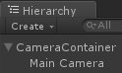

For examples of this, look in the Flyer and Maze scenes of the VR Samples project, where we move the camera within the scene.

### Camera Nodes

Left and right eye cameras are not created by Unity. If you wish to get the positions of those nodes, you must use the [InputTracking](http://docs.unity3d.com/ScriptReference/VR.InputTracking.html) class.

Should you wish to get the individual positions of the eyes within the scene - perhaps for testing reasons - use the sample script below, and attach this to your camera.

**KINECT**

<http://projects.ict.usc.edu/mxr/faast/>

[Zigfu.com](http://Zigfu.com) offers a development kit that supports Unity3D with Kinect using the Kinect for Windows SDK from Microsoft or the OpenNI/NITE software provided by PrimeSense. We have a commercial SDK and a watermarked version for free use with plenty of sample scenes and a community of developers on our google group ([unitykinect.com](http://unitykinect.com)). We also support compiling to the web player using our Zigfu Browser Plugin to transmit skeleton and camera data from the browser to Unity3D web player.

<https://groups.google.com/forum/#!forum/unitykinect>

<http://www.imaginativeuniversal.com/blog/post/2015/03/27/unity-5-and-kinect-2-integration.aspx>